Scalable Data Center Simulation
And Exploration of Future Alternatives

Yilei Fu Lihang Gong Yuanfeng Wen

Abstract: Today’s data centers may contain tens of thousands of computers with significant aggregate bandwidth requirements. The network architecture typically consists of a tree of routing and switching elements with progressively more specialized and expensive equipment moving up the network hierarchy. [1] In our teamwork, we simulated a special data center topology: Fat-Tree and applied its routing algorithm. Also we applied flow classification and flow rearrangement on this data center topology. Then, we found the Fat-Tree structure also have some drawbacks, which impelled us to find more new structures and new algorithms. We raise an overview of several future perspectives, like combining Fat-Tree structure and BCube structure.
Key Words: Data center, Fat-Tree, BCube, Software Defined Network.

Iintroduction

Our main purpose is to simulate the Fat-Tree data center structure and its routing algorithm. As we mentioned in abstract, we used Python and followed steps mentioned in the paper “A Scalable, Commodity Data Center Network Architecture”. First, we applied addressing algorithm in order to build a basic Fat-Tree data center architecture, named every end host, switch and core switch and allocated their IP addresses. Then, we established a prefix/suffix storing system called “CAM” and “TCAM” structure. Although we cannot simulate the “Accessing Memory” part using Python, we still applied the routing algorithm -- we added prefix tables and suffix tables in order to run query on them when packets are routing, which is, 2-level-table lookup routing algorithm. 2-level-table lookup routing algorithm can help switches find their output ports effectively. When combining with TCAM architecture, the insert complexity can be O(N), and the delete complexity can be O(N^2). N is the length of prefix/suffix. Particularly, we simulated a whole routing path from 10.0.2.3 to 10.0.1.2. Details are mentioned in the “Simulation” part.

In addition, we applied the flow classification algorithm in order to recognize subsequent packets of the same flow, and forward them on the same outgoing port. Also, we are able to periodically reassign a minimal number of flow output ports to minimize any disparity between the aggregate flow capacity of different ports.

Nevertheless, Fat-Tree architecture and 2-level-table lookup routing example are not the only solution for data centers. We also introduced other structures such as VL2, and BCube. [2][3]

Background
Fat-Tree Structure:
Fat tree has identical bandwidth at any bisections – Each layer has the same aggregated bandwidth. It can be built using cheap devices with uniform capacity:
– Each port supports same speed as end host
– All devices can transmit at line speed if packets are distributed uniform along available paths
In addition, it has great scalability: K-port switch supports 3k/4 servers

Simulation
In our simulation, we applied naming rules that the paper mentioned by using Python. We built a same structure as the picture shows. Mainly, we have 4 pods, which contains 4*(4/2)^2 switches, and each Edge-layer switch links to 2 end host, each Aggregation-layer switch links to 2 lower layer switches and two core switches. The addressing algorithm arranges switches and end hosts’ IP addresses.
We then ran some simulations using this DCN.
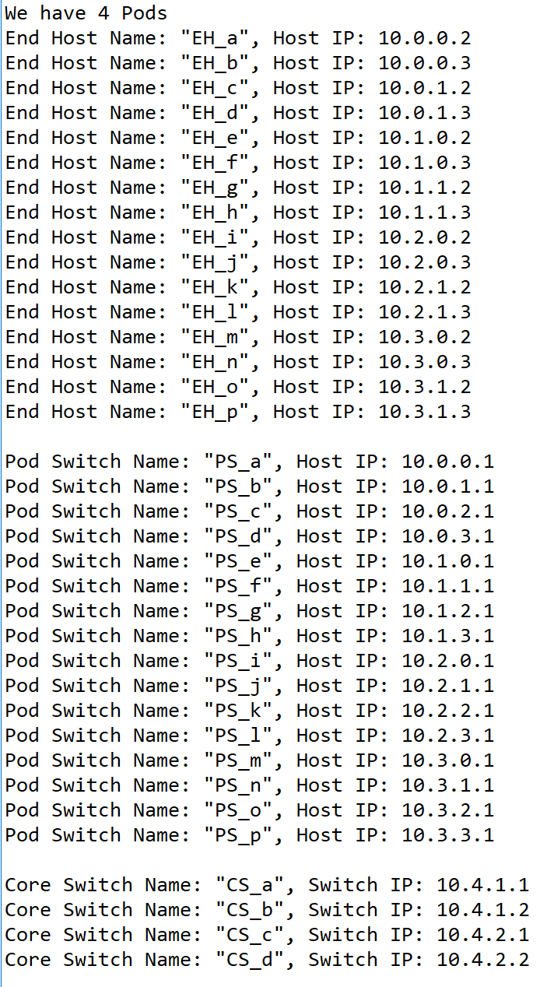
- Naming Algorithm
We also simulated routing table in each switch, assigned by specific algorithm. There are some differences between different layers. For example, core switches only have prefix tables because packets will not go up any more. When one packet comes to one switch, the switch will compare the packet destination IP with the table; first matches suffix table, then matches prefix table, and then decide which port the packet will export. In this way, the response time will be much shorter than traditional way. The result of our simulation shows in Figure 2.
After doing that, we can run main part of the simulation. This result shows the switches the packet went through from source host to destination host. (Shows in Figure3.) First, the gateway switch of the source host (10.0.1.1) will only match the packet with the /0 first-level prefix, and therefore will forward the packet according to the table. In that table, the packet matches the 0.0.0.3/8 suffix, which points to port 2 and switch 10.0.2.1. Switch 10.0.2.1 also follows the same steps and forwards on port 3, connected to core switch 10.4.1.1. The core switch matches the packet to a terminating 10.2.0.0/16 prefix, which points to the destination pod 2 on port 2, and switch 10.2.2.1. This switch belongs to the same pod as the destination subnet, and therefore has a terminating prefix, 10.2.0.0/24, which points to the switch responsible for that subnet, 10.2.0.1 on port 0. From there, switches deliver the packet to the destination host 10.2.0.3. The result shows in Figure 4.
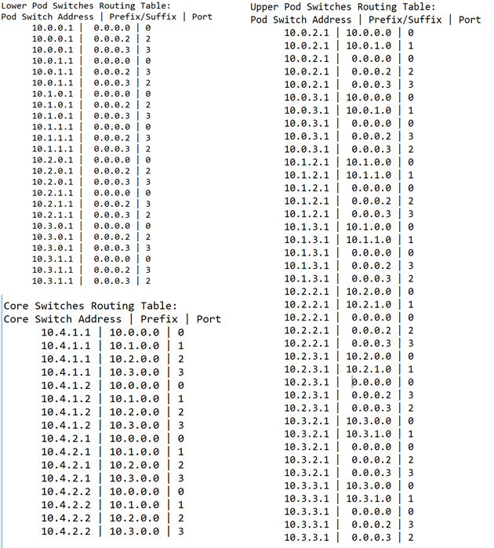
- Routing Tables
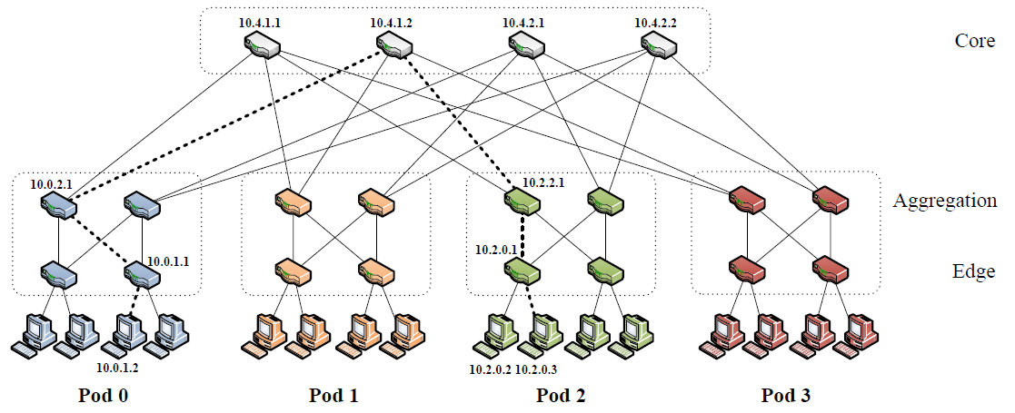
- Routing Path
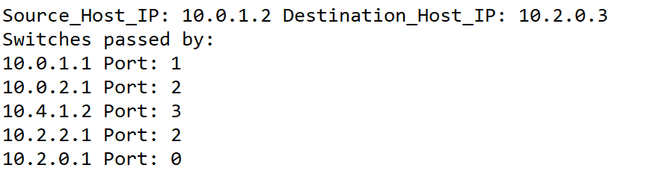
- Simulated Routing Path
We also ran several simulations on flow classification. When there is a new flow coming, we can run the flow classification algorithm in order to:
1. Recognize subsequent packets of the same flow, and forward them on the same outgoing port.
2. Periodically reassign a minimal number of flow output ports to minimize any disparity between the aggregate flow capacities of different ports.

Explanation of Future Alternatives
Fat-Tree structure is a structure centering on switches, the number of core switches limits its scalability. The flow-scheduling algorithm depends on core switches, which also limits its expandability. Although we do not need to run the query thanks to CAM and ICAM, it will still suffer a severe decrease of performance when a switch down.
Alternative Architectures: Dcell, BCube, which are structures centering on server. BCube provide multipath routing and load equalization. If switch is down, impact on performance could be buffered. In addition, Dcell have a high scalability. Architectures center on server have a larger scalability, but also a higher complexity.
In recent years, modular data center (MDC) has become a new approach to building datacenter. The BCube architecture serves as a suitable fundamental building block to realize a MDC design, which requires special features such as as higher network capacity and graceful performance degradation in the event of hardware failures.[4]
One of the reasons why BCube performs better in both metrics is due to its network architecture having multiple possible paths to send a traffic flow from point A to point B. This would bring about lesser traffic congestion and more available bandwidth.
Moreover, servers in the BCube architecture act as relay nodes and help one another to speed up packet routing and traffic flow, thus resulting in improved throughput and packet delay performance over the Fat tree architecture.
Our idea is to use the combination of center-on-server architecture and center-on-switch architecture. In a large data center, we can use center-on-server structure for a upper level network, like BCube, and use center-on-switch structure for a lower level network, like Fat-Tree. BCube Topology have a smaller scale and a better scalability, which can make the whole data center network occupy less storage space and maintain a higher scalability. Moreover, when there are some accidents happen, BCube structure can protect our loss to be minimum. In the meantime, Fat-Tree topology have a less routing complexity, the lower level of data center, which always have many hosts. A lower complexity can help the establishment of Data center network easier.

Acknowledgment
We cannot possibly finish this project if we did not receive Professor Shyam Parekh’s project reference, and we are grateful for his wonderful course this semester.
Our programming language is Python (3.5.2), 64bit. The coding environment is Windows 10.
Yilei Fu and Lihang Gong are concurrent enrollment student in UC Berkeley from Harbin Institute of Technology, China. Yuanfeng Wen is student from US Berkeley.
You can find the full version of our work on GitHub:
https://github.com/Fu-Yilei/EE122Project
For further questions, please do not hesitate to contact me: fuyilei96@berkeley.edu or fuyilei96@hit.edu.cn

References
- Al-Fares M et al (2008), A Scalable, Commodity Data Center Network Architecture
- https://www.cs.cornell.edu/courses/cs5413/2014fa/lectures/08-fattree.pdf
- https://www.microsoft.com/en-us/research/publication/bcube-a-high-performance-server-centric-network-architecture-for-modular-data-centers/
[4] Daji Wong, Kiam Tian Seow, “Towards Reproducible Performance Studies Of Datacenter Network Architectures Using An Open-Source Simulation Approach”

